**Starting Slash Screen**

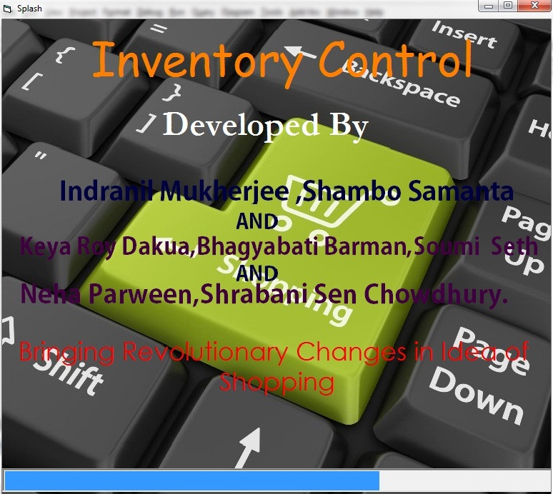

**SPLASH SCREEN: This is the Welcome Screen of Inventory Control Management System. When anyone starts the application, this splash screen is displayed. There is a progress bar in this screen whenever it is filled then it is redirected to the Welcome form.**

**Welcome1 Form (FORM 14)**

**CODE:**

**Private Sub Timer1_Timer ()**

**Dim str As String**

**str = Form14.Label1.Caption**

**str = Mid$(str, 2, Len (str)) + Left (str, 1)**

**Form14.Label1.Caption = str**

**End Sub**

**Private Sub Timer2_Timer ()**

**If ProgressBar2.Value < 100 Then**

**ProgressBar2.Value = ProgressBar2.Value + 1**

**ElseIf ProgressBar2.Value = 100 Then**

**Unload Me**

**Load Form1**

**Form1.Show**

**End If**

**End Sub**

**Private Sub Form_Load ()**

**Label1.Caption = Label1.Caption & Space (50)**

**Timer1.Enabled = True**

**End Sub**

**Welcome Form**

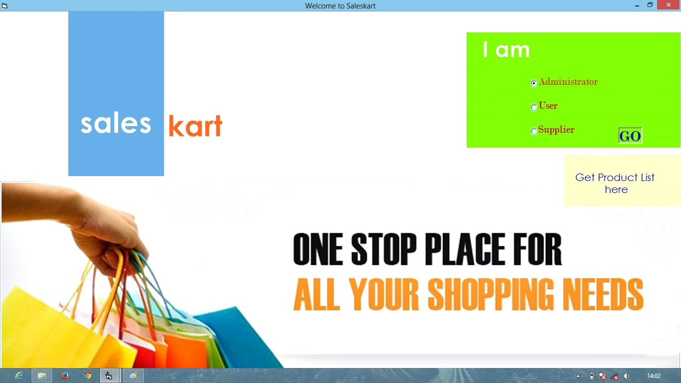

**In this MDI form several option buttons have been provided to directly go to the Administrator or User or Supplier Login Form with help of another label button “Go”. In addition to that there is another label “Get product list here” by which one can go to the sell form.**

**Form 1 (Welcome Form)**

**Code:**

Private Sub Form_Load()

Option1.Value = False

Option2.Value = False

Option3.Value = False

End Sub

Private Sub Label4_Click()

If Option1.Value = True Then

Unload Me

Load Form4

Form4.Show

ElseIf Option3.Value = True Then

Unload Me

Load Form3

Form3.Show

ElseIf Option2.Value = True Then

Unload Me

Load Form17

Form17.Show

End If

End Sub

Private Sub Label5_Click()

Unload Me

Load Form13

Form13.Show

End Sub

**Sales Form(Product list)**

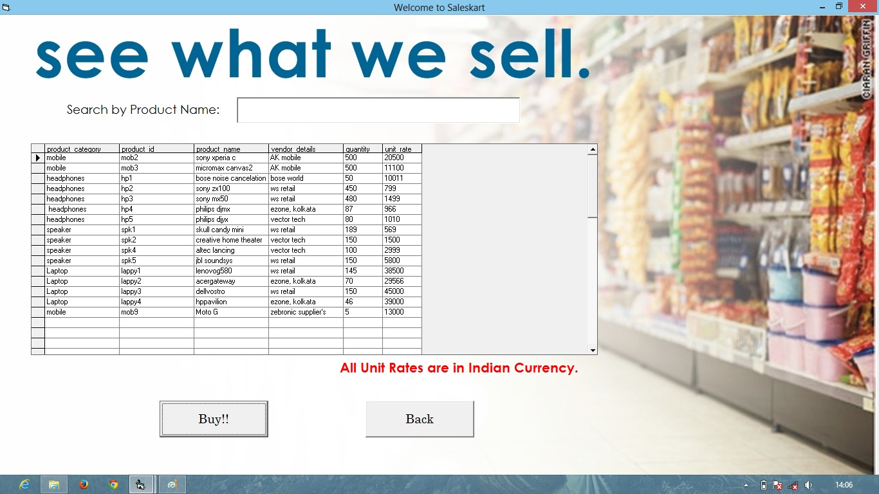

**In this MDI form a Data grid is provided which is connected to the “Saleskart.mdb’s” “prdkt table or simply it is connected to a database, which is updated automatically after buying or selling something. We can also find any specific product name by typing in the textbox provided. If we click on any row of that data grid we can buy it by clicking the “Buy!!” Command button. Also we can go back to the “Welcome form” by clicking the “Back” command button.**

**Form 13 (Sell Form)**

**Code:**

Dim rsPatient As ADODB.Recordset

Dim con As ADODB.Connection

Private Sub Command1_Click()

MsgBox "Please Login to Buy!!", vbInformation + vbOKOnly, "Sales Kart Says:"

Unload Me

Load Form3

Form3.Show

End Sub

Private Sub Command2_Click()

Unload Me

Load Form1

Form1.Show

End Sub

Private Sub Text1_Change()

If Text1.Text = "" Then

Call Form_Load

SrchRES. Open "select * from prdkt where product_name like '" & Trim (Text1.Text) & "%' or product_category like '" & Trim (Text1.Text) & "%' or product_id like '" & Trim (Text1.Text) & "%' order by (product_name)", con, adOpenStatic, adLockOptimistic

End If

End Sub

Private Sub Form_Load ()

Set con = New ADODB.Connection

con.Open

Set rsPatient = New ADODB.Recordset

Set DataGrid1.DataSource = rsPatient

End Sub

Private Sub Form_Unload (Cancel As Integer)

con.Close

End Sub

**Admin Form**

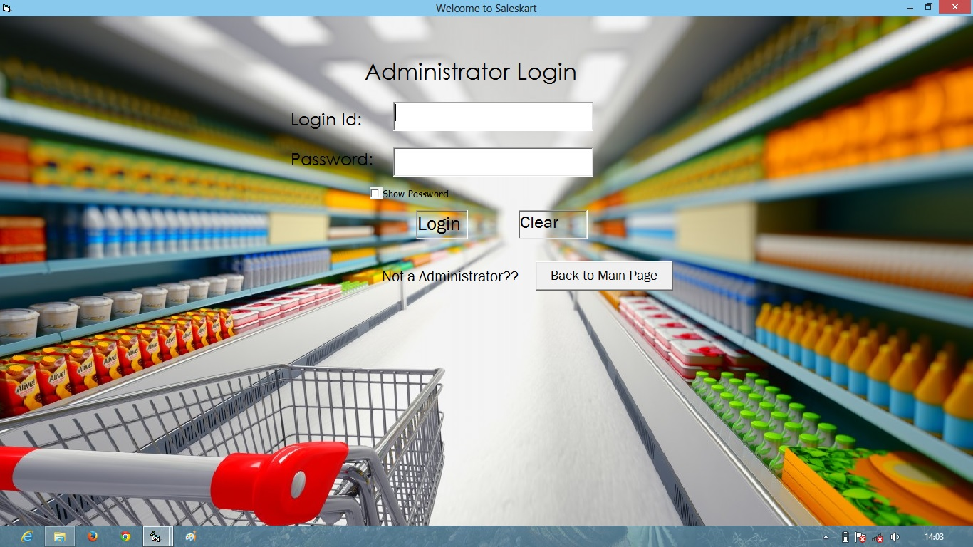

**In this MDI form two text boxes are provided. In those one have to write the correct login Id and password (by default which are “admin1” and “qwerty”). After writing them correctly we have to click on the “Login” label button which will take us to “Admin area” form else it will produce error msgbox. One also can clear those text boxes by clicking on the “Clear” label button. We can also go the Welcome page by clicking on the “Back to Main Page” command button.**

**Form 4 (Admin Form)**

**Code:**

Private Sub Command1_Click ()

Unload Me

Load Form1

Form1.Show

End Sub

Private Sub Label4_Click ()

If Text1.Text = "admin1" And Text2.Text = "qwerty" Then

Unload Me

Load Form5

Form5.Show

Else

MsgBox ("Wrong Username or Password."), vbInformation, "Saleskart Says.”

End If

End Sub

Private Sub Label5_Click ()

Text1.Text = ""

Text2.Text = ""

End Sub

**Admin Area(system admin area)**

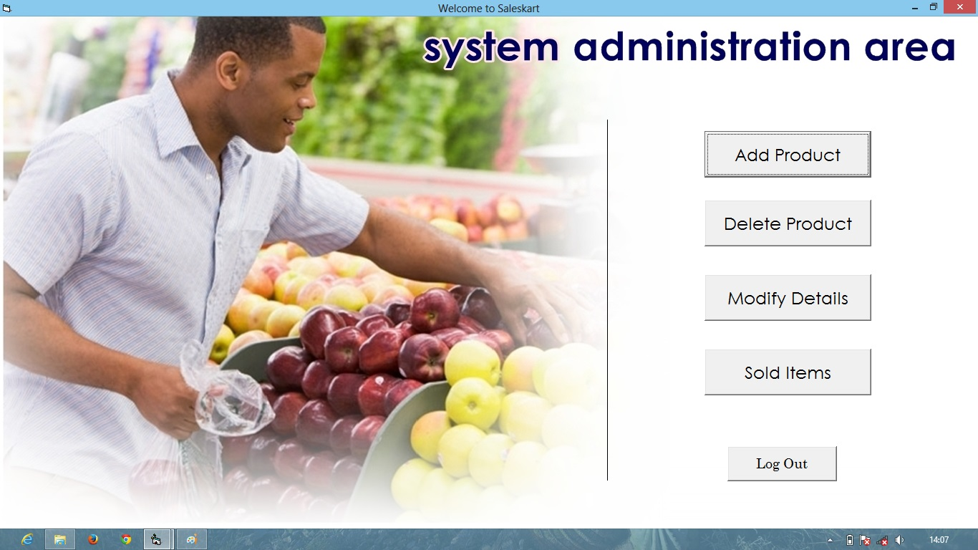

**In this MDI form several command buttons have been provided. By clicking on the:-**

**(i) “Add product” command button we can go to the “add product” form.**

**(ii) “Delete product” command button we can go to the “delete product” form.**

**(iii) “Modify Details” command button we can go to the “modification” form.**

**(iv) “Sold Items” command button we can go to the “sold items” form.**

**(v) “Log Out” command button we can go back to the “Welcome” form.**

**Form 5 (Admin area Form)**

**Code:**

Private Sub Command1_Click ()

Form6.Show

Form5.Hide

End Sub

Private Sub Command2_Click ()

Form7.Show

Form5.Hide

End Sub

Private Sub Command4_Click ()

MsgBox "You Have to Login Again After Checking This! Hope See u soon", vbOKOnly, "SalesKart Says"

Load Form19

Form19.Show

Form5.Hide

End Sub

Private Sub Command3_Click ()

Form8.Show

Form5.Hide

End Sub

Private Sub Command5_Click ()

MsgBox "Logout Successful! Hope See u soon", vbOKOnly, "SalesKart Says"

Form1.Show

Unload Me

End Sub

**Add product Form**

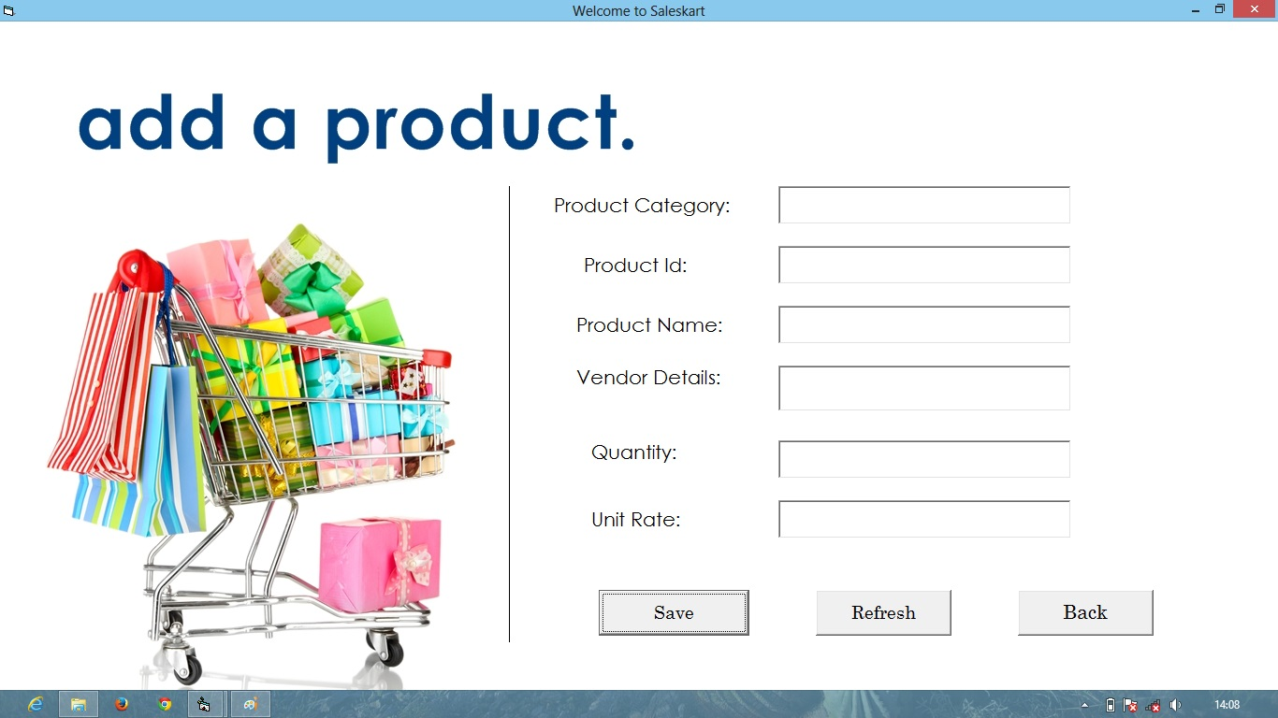

**In this MDI form following Text Boxes have been provided for the adding a product to the database:-**

**1.**                  **Product Category**

**2.**                  **Product Id.**

**3.**                  **Product Name**

**4. Vendor Details**

**5.**                  **Quantity**

**6.**                  **Unit Rate**

**In addition to above different Save, Refresh, Back command buttons have been provided in the form. “Save” button will save the following data’s into the database. Refresh button will clear all the Text boxes and “Back” button will take us to “Welcome form”.**

**Form 6 (Add Product Form)**

**Code:**

Dim con As ADODB.Connection

Dim res As ADODB.Recordset

Private Sub Form_Load()

Set con = New ADODB.Connection

Set res = New ADODB.Recordset

con.ConnectionString = "Provider=Microsoft.Jet.OLEDB.4.0;Data Source=E:\project VB\SalesKart.mdb;Persist Security Info=False"

con.Open

res.Open "select * from prdkt", con, adOpenStatic, adLockOptimistic

End Sub

Private Sub Command1_Click()

res.AddNew

res.Fields ("product_category") = Text1.Text

res.Fields ("product_id") = Text2.Text

MsgBox ("Product Saved Successfully. "), vbInformation, "Sales Kart Says:"

Unload Me

Load Form5

Form5.Show

End Sub

Private Sub Command3_Click()

Unload Me

Load Form5

Form5.Show

End Sub

**Delete Product form**

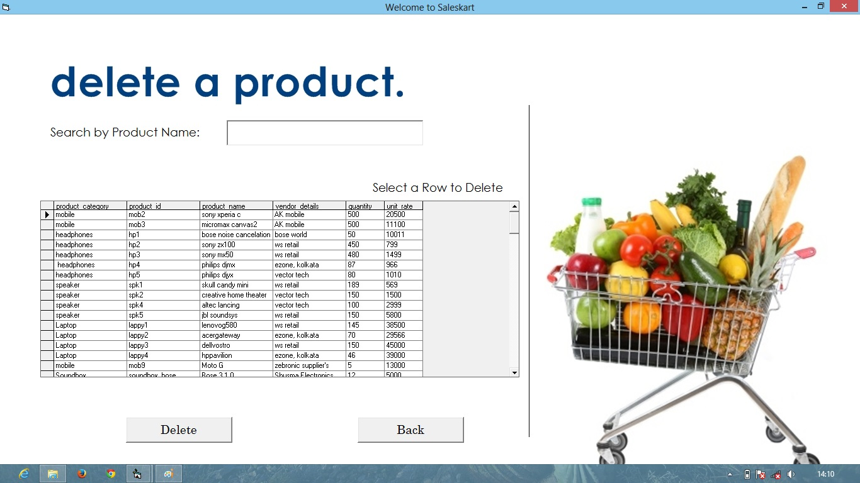

In this MDI Form a Data grid is used which uses SalesKart.mdb database’s prdkt table.

Here a “Search by product Name” text box is added which is used to search any rows of the data grid by comparing it with this Data grid’s row name. After one row is selected we can click on the “Delete” command button to delete the selected row or we can go back to the “Welcome form” by clicking the “Back” command button.

**Form 7 (Delete Product Form)**

**Code:**

Dim con As ADODB.Connection

Dim res, srchRES As ADODB.Recordset

Dim fast As Date

Dim saver As Integer

Private Sub Command4_Click()

Unload Me

Load Form5

Form5.Show

End Sub

Private Sub Form_Load()

Set con = New ADODB.Connection

Set res = New ADODB.Recordset

con.CursorLocation = adUseClient

con.Open

res.Open "select * from prdkt", con, adOpenStatic, adLockOptimistic

End Sub

Private Sub DelBtn_Click()

If Text1.Text = "" Then

ans = MsgBox("Are U Sure to Delete the Record???", vbExclamation + vbYesNo, "Delete Record")

If ans = vbYes Then

res.Delete

res.MoveFirst

End If

Else

ans = MsgBox("Are U Sure to Delete the Record???", vbExclamation + vbYesNo, "Delete Record")

If ans = vbYes Then

srchRES.Delete

srchRES.MoveFirst

End If

End If

End Sub

Private Sub delete_Click(Index As Integer)

If Text1.Text = "" Then

ans = MsgBox("Are U Sure to Delete the Record???", vbExclamation + vbYesNo, "Delete Record")

If ans = vbYes Then

res.Delete

res.MoveFirst

End If

Else

ans = MsgBox("Are U Sure to Delete the Record???", vbExclamation + vbYesNo, "Delete Record")

If ans = vbYes Then

srchRES.MoveFirst

End If

End Sub

Private Sub Text1_Change()

If Text1.Text = "" Then

Call Form_Load

Else

Set DataGrid1.DataSource = srchRES

End If

End Sub

Private Sub Form_Unload(Cancel As Integer)

con.Close

End Sub

**Modification Form**

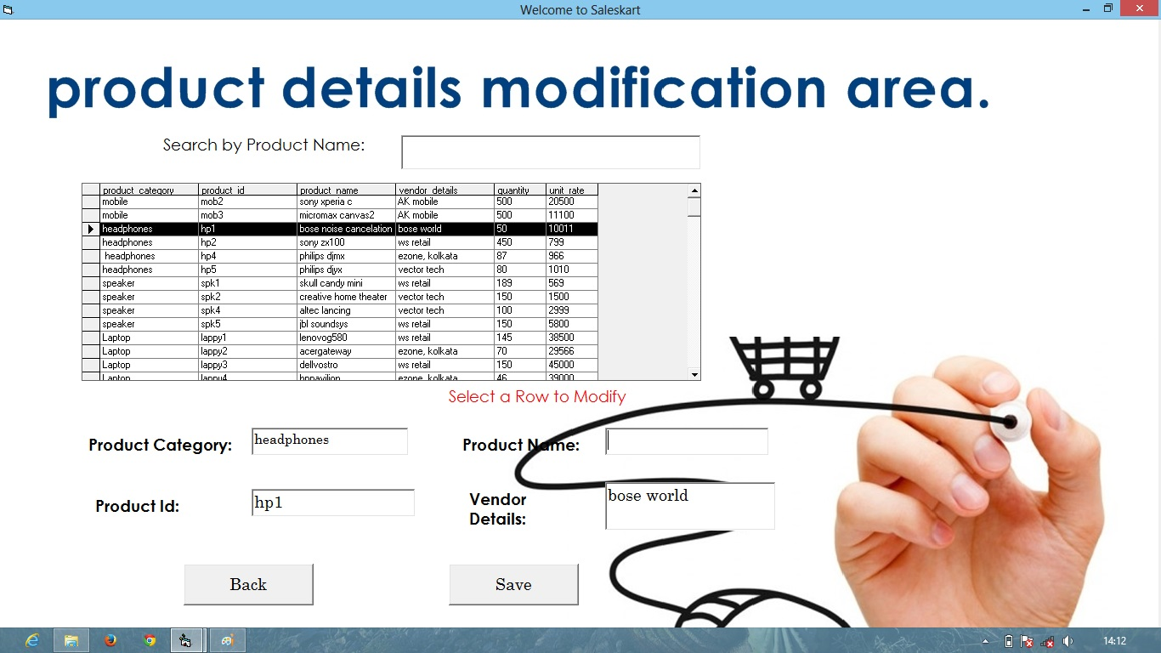

**In this MDI form a Data grid is provided which is connected to Saleskart.mdb’s prdkt table or simply it is connected to a database, which is updated automatically after modifying something. We can also search any specific product name by typing in the textbox provided. If we click on any row of that data grid we can change its “Product category” or “Product Name” or “Product Id” or “Vendor Details” by changing the corresponding Text boxes and after that clicking on the “Save” Command button. Also we can go back to the “Welcome form” by clicking the “Back” command button.**

**Form 8 (Modification Form)**

**Code:**

Dim con As ADODB.Connection

Dim res, res2, srchRES, and srchRES2 As ADODB.Recordset

Private Sub Command1_Click ()

Unload Me

Load Form5

Form5.Show

End Sub

Private Sub DataGrid1_Click ()

If Text1.Text = "" Then

TBdisp

Else

TBlock

End If

End Sub

Private Sub Form_Load ()

Set con = New ADODB.Connection

Set res = New ADODB.Recordset

con.ConnectionString = "Provider=Microsoft.Jet.OLEDB.4.0; Data Source=E:\project VB\SalesKart.mdb;Persist Security Info=False"

con.Open

res.Open "select * from prdkt", con, adOpenStatic, adLockOptimistic

End Sub

Private Sub funcSave ()

If Text1.Text = "" Then

res.Fields ("product_category") = Text2.Text

res.Fields ("product_id") = Text3.Text

res.Update

MsgBox ("Record Modified Successfully. "), vbInformation, "SalesKart Says.”

Else

srchRES.Fields ("product_category") = Text2.Text

srchRES.Fields ("product_id") = Text3.Text

MsgBox ("Record Modified Successfully. "), vbInformation, "SalesKart Says.”

TBlock

End If

End Sub

Private Sub Text1_Change ()

Call Form_Load

Else

Set srchRES = New Recordset

Set DataGrid1.DataSource = srchRES

End If

End Sub

Private Sub Text4_GotFocus ()

Text4.Text = ""

End Sub

Private Sub TBdisp ()

Text4.Text = res.Fields ("product_name")

Text5.Text = res.Fields ("vendor_details")

End Sub

Private Sub TBlock () *End Sub

Text2.Locked = True Private Sub TBdisp2 ()

Text5.Locked = True Text2.Text = srchRES.Fields ("product_category")

End Sub End Sub

Private Sub TBunlock () Private Sub Form_Unload (Cancel As Integer)

Text2.Locked = False con.Close

Text3.Locked = False * End Sub

**Sold Items Form**

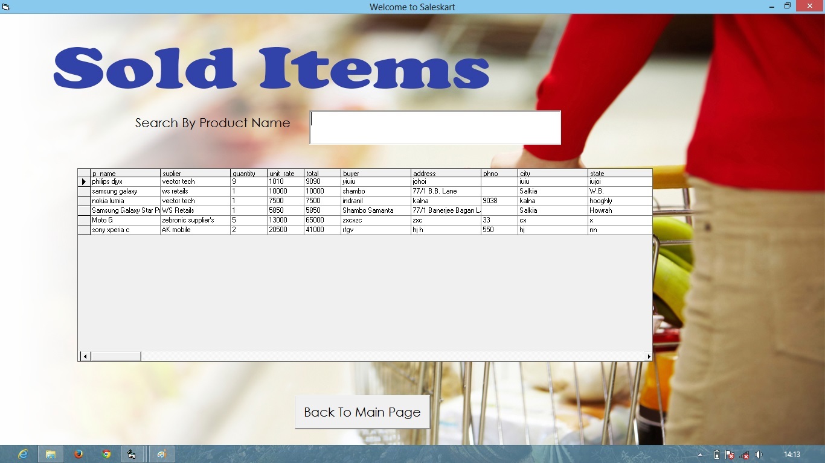

**This MDI form contains all the products which are already sold. In this MDI form a Data grid is provided which is connected to “Saleskart.mdb’s prdkt” table or simply it is connected to a database, which is updated automatically buying something. We can also find any specific product name by typing in the textbox provided. Also we can go back to the “Welcome form” by clicking the “Back To Main Page” command button.**

**Form 19 (Sold Items Form)**

**Code:**

Dim rsPatient As ADODB.Recordset

Dim con As ADODB.Connection

Private Sub Command1_Click()

Unload Me

Load Form1

Form1.Show

End Sub

Private Sub Text1_Change()

Set srchRES = New Recordset

DataGrid1.Refresh

End Sub

Private Sub Form_Load ()

Set con = New ADODB.Connection

con.ConnectionString = "Provider=Microsoft.Jet.OLEDB.4.0; Data Source=E:\project VB\SalesKart.mdb;Persist Security Info=False"

con.Open

Set rsPatient = New ADODB.Recordset

Set DataGrid1.DataSource = rsPatient

End Sub

Private Sub Form_Unload (Cancel As Integer)

con.Close

End Sub

**Supplier Login Form**

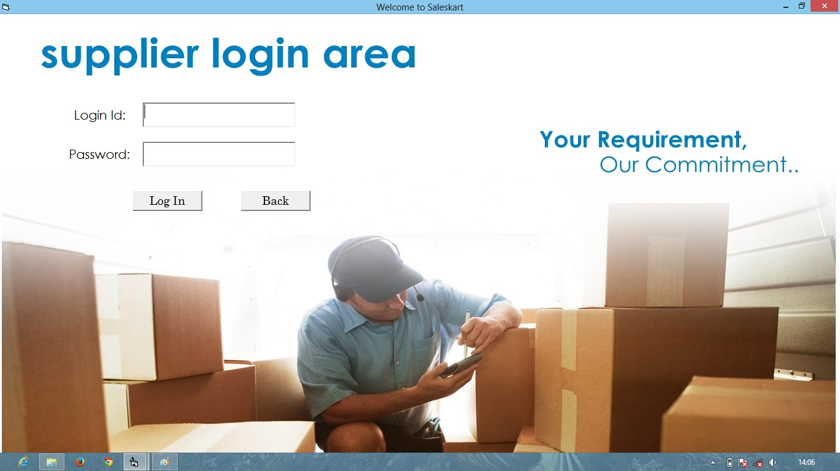

**In this MDI form two text boxes are provided. In those one have to write the correct login Id and password (by default which are "vendor1" and “qwerty”). After writing them correctly we have to click on the “Log In” command button which will take us to “Supplier Update area” form else it will produce error msgbox.We can also go the Welcome page by clicking on the “Back” command button.**

**Form 17 (Supplier Login Form)**

**Code:**

Private Sub Command1_Click()

If Text1.Text = "vendor1" And Text2.Text = "qwerty" Then

MsgBox "Login Successful!", vbOKOnly, "SalesKart Says"

Unload Me

Load Form18

Form18.Show

Else: MsgBox “Username or Password Mismatched!!", vbOKOnly, "SalesKart Says"

Text1.Text = ""

Text2.Text = ""

Text1.SetFocus

End If

End Sub

Private Sub Command2_Click ()

Unload Me

Load Form1

Form1.Show

End Sub

**Supplier Update Form**

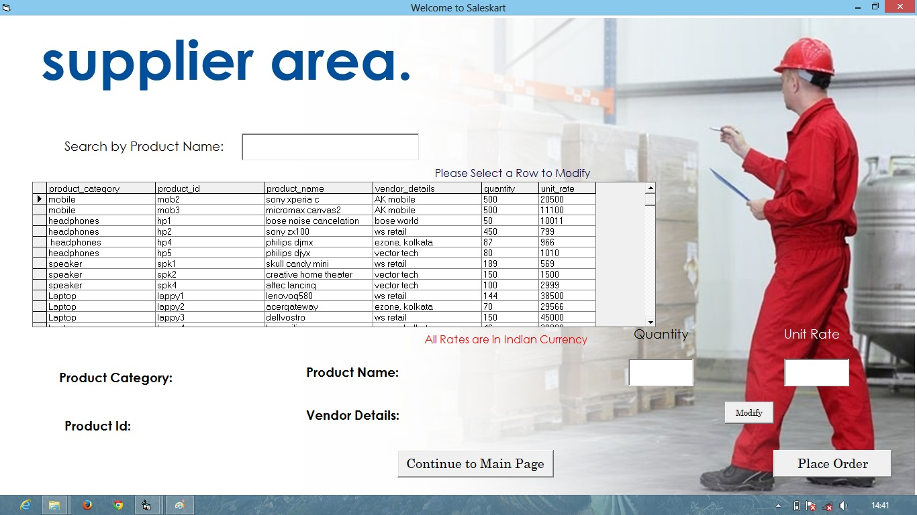

**In this MDI form a Data grid is provided which is connected to Saleskart.mdb’s prdkt table or simply it is connected to a database, which is updated automatically after modifying something (Only a supplier can modify product “Quantity” and “Unit Rate”). We can also search any specific product name by typing in the textbox provided. If we click on any row of that data grid we can change its “Quantity” and “Unit Rate” by clicking on the “Modify” command button then changing the corresponding Text boxes and after that clicking on the “Place Order” Command button. Also we can go back to the “Welcome form” by clicking the “Continue to Main Page” command button.**

**Form 18 (Supplier Update Form)**

**Code:**

Dim con As ADODB.Connection

Dim res, srchRES As ADODB.Recordset

Dim fast As Date

Dim saver As Integer

Private Sub Command5_Click()

MsgBox ("Order will be delivered soon. "), vbInformation, "SalesKart says.”

End Sub

Private Sub Command6_Click()

Unload Me

Load Form1

Form1.Show

End Sub

Private Sub DataGrid2_Click()

If Text1.Text = "" Then

TBdisp

Else

TBdisp2

End If

End Sub

Private Sub Form_Load()

Set con = New ADODB.Connection

Set res = New ADODB.Recordset

Set res2 = New ADODB.Recordset

con.ConnectionString = "Provider=Microsoft.Jet.OLEDB.4.0;Data Source=E:\project VB\SalesKart.mdb;Persist Security Info=False"

con.Open

res.Open "select * from prdkt", con, adOpenStatic, adLockOptimistic

End Sub

Private Sub funcSave()

If Text1.Text = "" Then

res.Fields ("quantity") = Text2.Text

res.Fields ("unit_rate") = Text3.Text

MsgBox ("Record Saved Successfully. "), vbInformation, "SalesKart Says.”

Else

SrchRES. Fields ("quantity") = Text2.Text

SrchRES. Fields ("unit_rate") = Text3.Text

MsgBox ("Record Saved Successfully. "), vbInformation, "Saleskart Says.”

End If

End Sub

Private Sub btnModify_Click()

If btnModify.Caption = "Modify" Then

ans = MsgBox ("Are U Sure to Modify the Record???", vbInformation + vbYesNo, "Modify Record")

If ans = vbYes Then

Text1.SetFocus

btnModify.Caption = "SAVE"

End If

Else If btnModify.Caption = "SAVE" Then

btnModify.Caption = "Modify"

End If

End Sub

Private Sub Text1_Change ()

If Text1.Text = "" Then

Call Form_Load

Else

Set srchRES = New Recordset

Set DataGrid2.DataSource = srchRES

TBdisp2

End If

End Sub

Private Sub TBdisp ()

Label6.Caption = res.Fields ("product_category")

Label7.Caption = res.Fields ("product_id")

Label8.Caption = res.Fields ("product_name")

Label9.Caption = res.Fields("vendor_details")

End Sub

Private Sub TBunlock()

Text2.Locked = False

Text3.Locked = False

End Sub

Private Sub TBdisp2 ()

Label6.Caption = srchRES.Fields ("product_category")

Label7.Caption = srchRES.Fields ("product_id")

Text3.Text = srchRES.Fields ("unit_rate")

End Sub

Private Sub Form_Unload (Cancel As Integer)

con.Close

End Sub

**New User Registration Form**

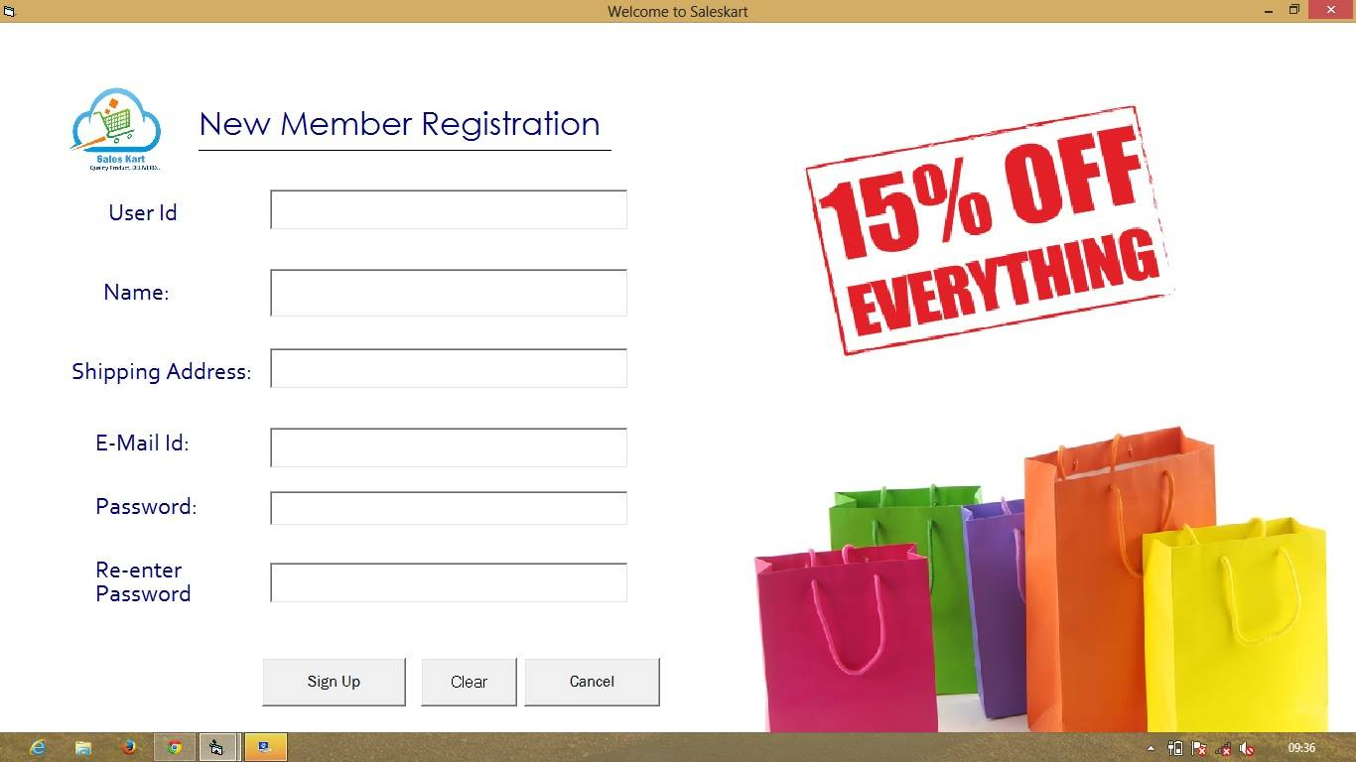

**In this MDI form following Text Boxes have been provided for adding different data’s to the database (which will be later used for Logging In as User) :-**

**1.**                  **User Id**

**2.**                  **Name**

**3.**                  **Shipping address**

**4. Email-Id**

**5.**                  **Password**

**6.**                  **Re-enter Password**

**In addition to above “Sign Up”, “Clear” and “Cancel” command buttons have been provided in the form. “Sign Up” button will save the following data’s into the database and will use them in for User Log In purpose. “Clear” button will clear all the Text boxes and “Cancel” button will take us to “Welcome form”. Actually only “User Id” and “Password” is stored to the database.Re-enter Password will compared itself with password field and it those are not correct it will produce error msgbox.**

**Form 2(New User Reg.)**

**Code:**

Dim con As ADODB.Connection

Dim res As ADODB.Recordset

Private Sub Command2_Click ()

Load Form1

Form1.Show

End Sub

Private Sub Command3_Click ()

Text1.Text = ""

Text2.Text = ""

End Sub

Private Sub Command1_Click ()

If Text4.Text = Text5.Text Then

res.Fields ("user id") = Text1.Text

res.Fields ("password") = Text4.Text

MsgBox ("User account created. "), vbInformation, "Sales Kart Says:"

Unload Me

Load Form3

Form3.Show

Else

MsgBox ("Password Mismatched. "), vbInformation, "Sales Kart Says:"

End Sub

Private Sub Form_Unload (Cancel As Integer)

End Sub

**User Login Form**

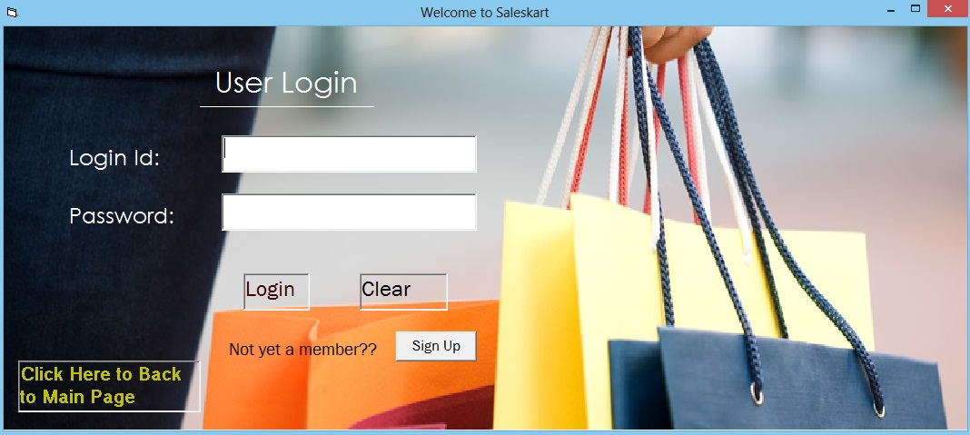

**In this MDI form two text boxes are provided. In those one have to write the correct login Id and password which will be compared with the SalesKart.mdb’s “tblusr” table’s “user id” and “password” column . After writing them correctly we have to click on the “Login” label button which will take us to “Admin area” form else it will produce error msgbox. One also can clear those text boxes by clicking on the “Clear” label button. We can also go the Welcome page by clicking on the “Click Here to Back to Main Page” command button. We can also create our own “Login Id” and “Password” by clicking on the “Sign Up” command button which will take us to “New User Reg.” form.**

**Form 3 (User Login Form)**

**Code:**

Dim con As ADODB.Connection

Dim res As ADODB.Recordset

Private Sub Label4_Click()

res.Open "select * from tblusr", con, adOpenDynamic, adLockOptimistic

While res.EOF = False

Unload Me

Load Form9

Form9.Show

Exit Sub

Else

res.MoveNext

End If

res.Close

End Sub

Private Sub Label5_Click()

Text1.Text = ""

Text1.SetFocus

End Sub

Private Sub Label7_Click()

Unload Me

Load Form1

Form1.Show

End Sub

**User Shopping form**

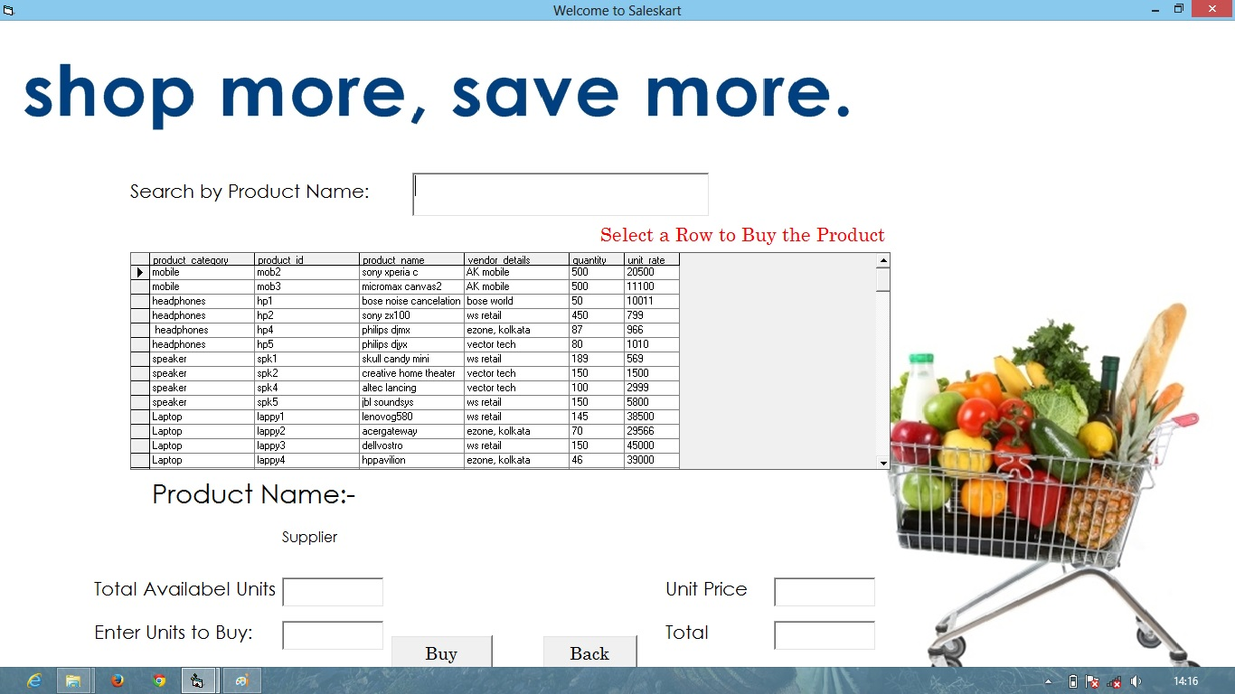

**In this MDI form a Data grid is provided which is connected to the “Saleskart.mdb’s” “prdkt table or simply it is connected to a database, which is updated automatically after selling something. We can also find any specific product name by typing in the textbox provided. If we click on any row of that data grid we can buy it by clicking the “Buy” Command button which will take us to shipping form. All the text boxes (“Total available units”, “Enter Units to Buy”, “Unit Price”, and “Total”) will be filled with the items in selected row. Also we can go back to the “Welcome form” by clicking the “Back” command button.**

**Form 9 (User Shopping Form)**

**Code:**

Dim con As ADODB.Connection

Dim res, res2, srchRES, srchRES2 As ADODB.Recordset

Dim fast As Date

Dim saver As Integer

Private Sub Command3_Click()

Unload Me

Load Form1

Form1.Show

End Sub

Private Sub Form_Load()

Set con = New ADODB.Connection

Set res = New ADODB.Recordset

Set res2 = New ADODB.Recordset

con.ConnectionString = "Provider=Microsoft.Jet.OLEDB.4.0;Data Source=E:\project VB\SalesKart.mdb;Persist Security Info=False"

con.Open

res.Open "select * from prdkt", con, adOpenStatic, adLockOptimistic

res2.Open "select * from sold", con, adOpenStatic, adLockOptimistic

Set DataGrid1.DataSource = res

End Sub

Private Sub btnModify_Click()

If Val(Text2.Text) <= Val(Text3.Text) Then

ans = MsgBox("Are U Sure to Buy the Product???", vbInformation + vbYesNo, "Saleskart Says. ")

If ans = vbYes Then

Call funcSave

res2.AddNew

res2.Fields("p_name") = Label7.Caption

res2.Fields("quantity") = Text2.Text

res2.Fields("total") = Text5.Text

res2.Update

Unload Me

Load Form10

Form10.Show

End If

Else

MsgBox ("Out of stock "), vbInformation, "Saleskart Says. "

End If

End Sub

End Sub

Private Sub TBlock()

Text3.Locked = True

End Sub

Private Sub TBclear()

Text2.Text = ""

Text5.Text = ""

End Sub

Private Sub TBdisp2()

Label7.Caption = srchRES.Fields("product_name")

Label6.Caption = srchRES.Fields("vendor_details")

End Sub

Private Sub Form_Unload(Cancel As Integer)

con.Close

End Sub

**Product Shipping**

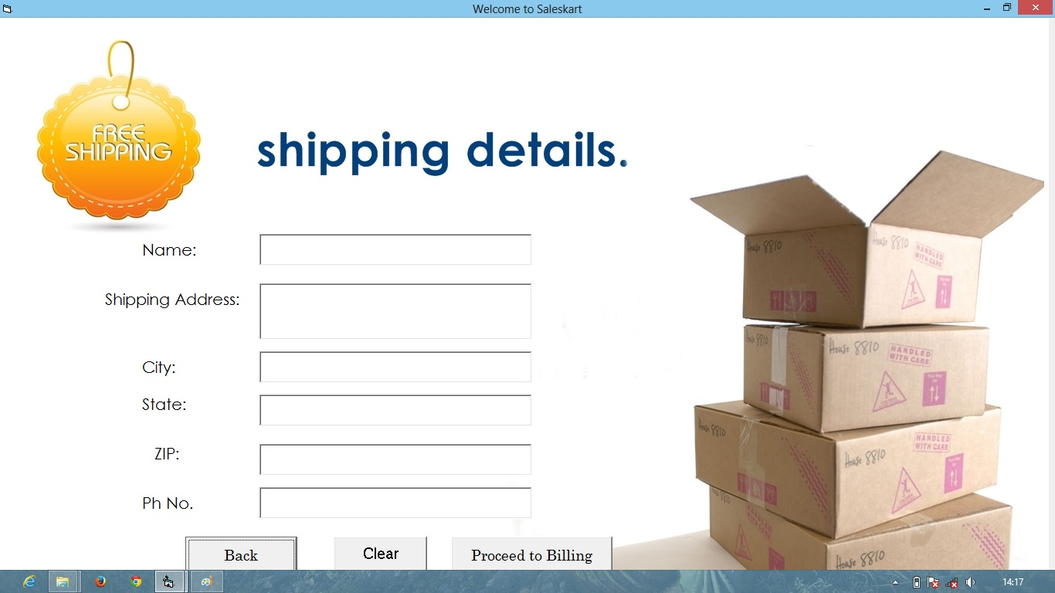

**In this MDI form following Text Boxes have been provided for the adding different data’s to the database (which will be later used for the Bill and in Sold items database) :-**

**1.**                  **Name**

**2.**                  **Shipping Address**

**3.**                  **City**

**4. State**

**5.**                  **ZIP**

**6.**                  **Ph. No.**

**In addition to above “Proceed to Billing”, “Clear” and “Back” command buttons have been provided in the form. “Proceed to Billing” button will save the following data’s into the database and will use them in for billing purpose. “Clear” button will clear all the Text boxes and “Back” button will take us to “Welcome form”.**

**Form 10 (Shipping Form)**

**Code:**

Dim con As ADODB.Connection

Dim res As ADODB.Recordset

Private Sub Command1_Click ()

Unload Me

Load Form1

Form1.Show

End Sub

Private Sub Command3_Click ()

Text1.Text = ""

Text2.Text = ""

Text3.Text = ""

Text4.Text = ""

Text5.Text = ""

Text6.Text = ""

End Sub

Private Sub Form_Load ()

Set con = New ADODB.Connection

Set res = New ADODB.Recordset

con.ConnectionString = "Provider=Microsoft.Jet.OLEDB.4.0; Data Source=E: \project VB\SalesKart.mdb; Persist Security Info=False"

con.Open

res.Open "select * from sold", con, adOpenStatic, adLockOptimistic

End Sub

Private Sub Command2_Click()

res.Fields ("buyer") = Text1.Text

res.Fields ("address") = Text2.Text

res.Fields ("phno") = Text6.Text

res.Fields ("city") = Text3.Text

res.Fields ("state") = Text4.Text

res.Fields ("zip") = Text5.Text

res.Update

Msgbox ("Product Will be shifted in a day. "), vbInformation, "Sales Kart Says:"

Unload Me

Load Form16

Form16.Show

End Sub

Private Sub Form_Unload (Cancel As Integer)

con.Close

End Sub

**User Bill**

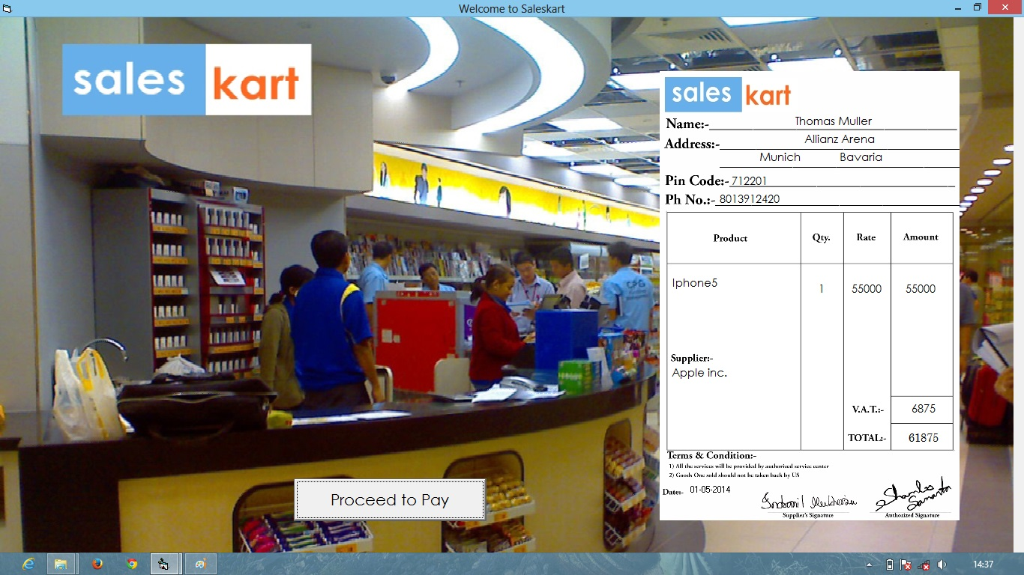

**This MDI form contains the product which the currently logged user bought. In this MDI form different labels are used which is connected to “Saleskart.mdb’s prdkt” table or simply it is connected to a database, which is updated automatically buying something and the labels get changed according to last bought items and shipping address. It also fetches dates from the system’s date.**

**Here a command button “Proceed to Pay” is used which will take us to “Pay” form.**

**Form 16 (User Bill Form)**

**Code:**

Dim con As ADODB.Connection

Dim res As ADODB.Recordset

Private Sub Command1_Click()

Unload Me

Load Form11

Form11.Show

End Sub

Private Sub Form_Load()

Set con = New ADODB.Connection

Set res = New ADODB.Recordset

con.ConnectionString="Provider=Microsoft.Jet.OLEDB.4.0;DataSource=E:\projectVB\SalesKart.mdb;Persist Security Info=False"

res.Open "select * from sold", con, adOpenStatic, adLockOptimistic

con.Open

End Sub

Private Sub Form_Unload(Cancel As Integer)

con.Close

End Sub

**Pay Form**

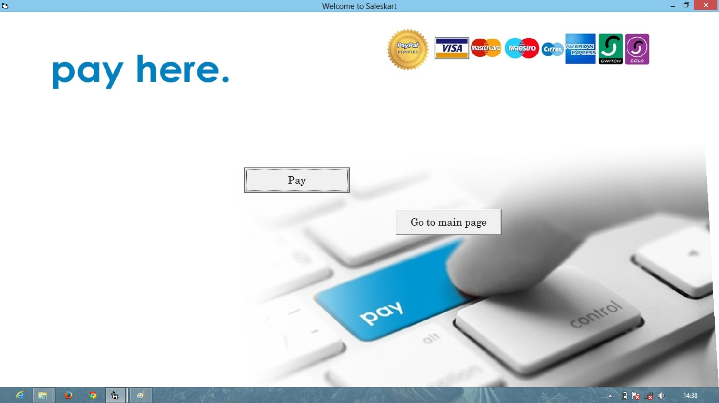

**In this MDI form Two Command buttons have been provided. The “Pay” command button will produce an msgbox about successful purchasing related and it will lead to the “thank you” form. There is another command button “Go to main page” which will lead us to the “welcome form”.**

**Form 11 (Pay Form)**

**Code:**

Private Sub Command2_Click ()

Msgbox "Paid Successfully!!”. vbInformation + vbOKOnly, "Sales Kart Says:"

Unload Me

Load Form15

Form15.Show

End Sub

Private Sub Command3_Click()

Unload Me

Load Form1

Form1.Show

End Sub

**Thank You Form ☺**

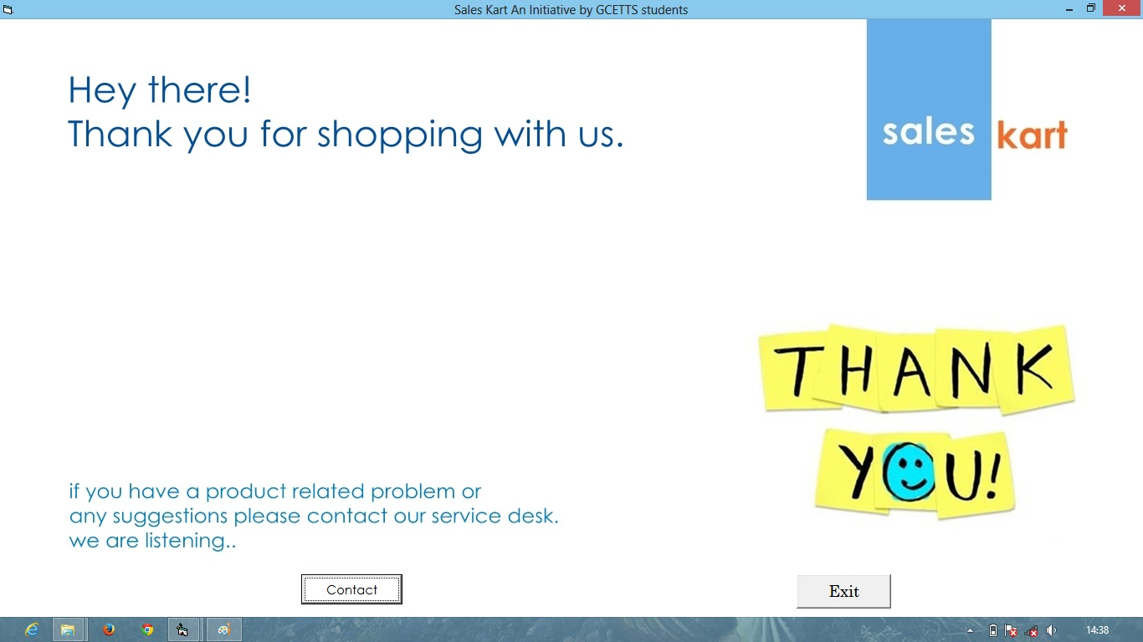

**In this MDI form Two Command buttons have been provided. The “Contact” command button will lead us to the “contact us” form. There is another command button “Exit” which will close down this application.**

**Form 15 (Thank you Form)**

**Code:**

Private Sub Command1_Click()

Unload Me

Load Form12

Form12.Show

End Sub

Private Sub Command2_Click()

MsgBox "Thank you!!Hope see u soon.", vbInformation + vbOKOnly, "Sales Kart Says:"

Unload Me

End Sub

**Contact Us Form**

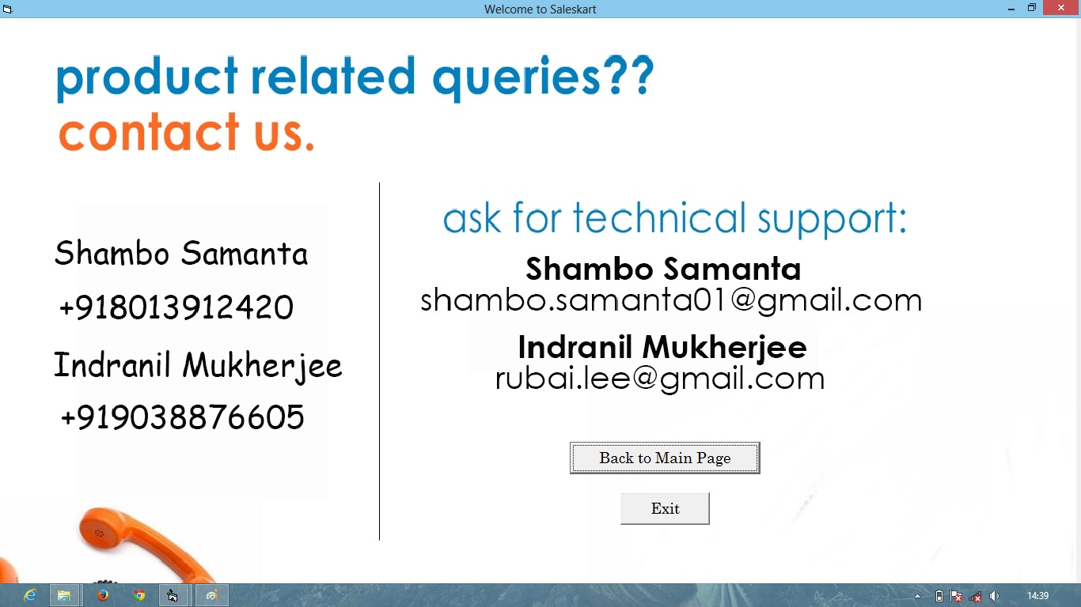

**In this MDI form Two Command buttons have been provided. The “Back to Main Page” command button will lead us to the “Welcome” form. There is another command button “Exit” which will close down this application.**

**Form 12 (Contact us Form)**

**Code:**

Private Sub Command1_Click()

Unload Me

Load Form1

Form1.Show

End Sub

Private Sub Command2_Click()

Unload Me

End Sub